CO4-AT2-LAB PRACTICE
1.JAVA APPLET LIFECYCLE :-
JAVA CODE:
import java.applet.Applet;
import java.awt.Graphics;
public class LifeCycle extends Applet {
public void init() {
System.out.println("init");
}
public void start() {
System.out.println("start");
}
public void paint(Graphics g) {
g.drawString("Applet Life Cycle ", 100, 100);
System.out.println("paint");
}
public void stop() {
System.out.println("stop");
}
public void destroy() {
System.out.println("destroy");
}
}
HTML CODE:
<html>
<body>
<applet code="LifeCycle.class" width="400" height="300">
</applet>
</body>
</html>
OUTPUT:
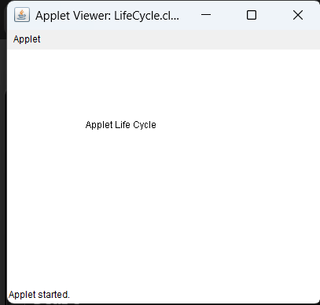
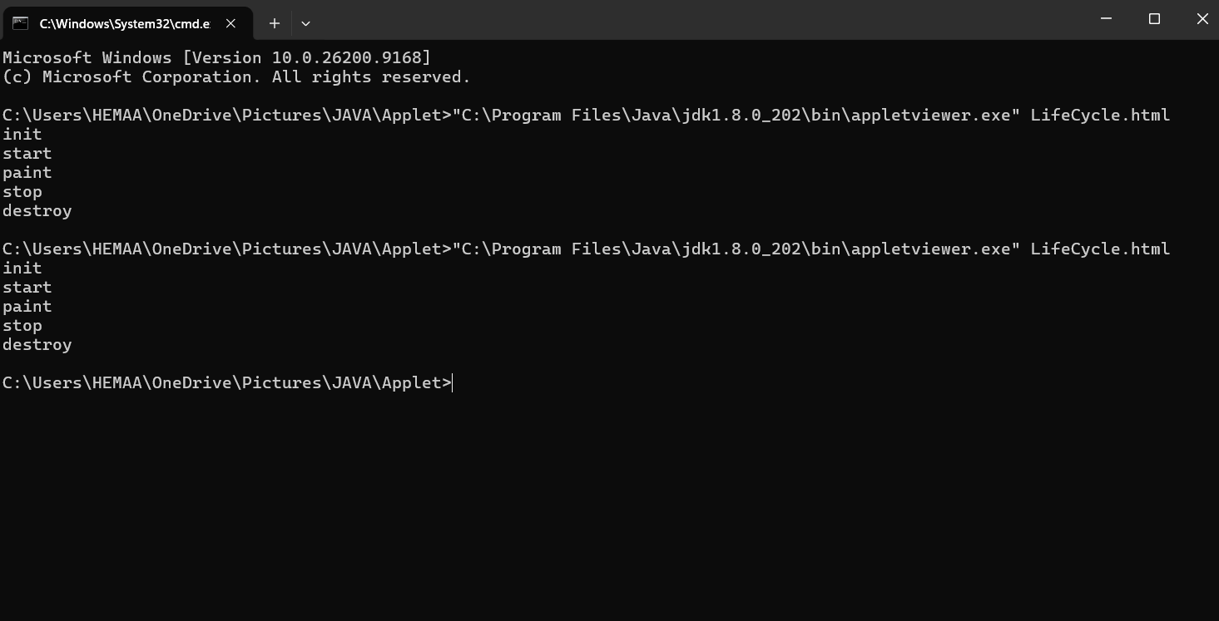

2.JAVA APPLET SHAPES : -
JAVA CODE:
import java.applet.Applet;
import java.awt.*;
public class Scene extends Applet {
public void paint(Graphics g) {
setBackground(Color.CYAN);
g.setColor(Color.YELLOW);
g.fillOval(50, 40, 70, 70);
g.setColor(Color.WHITE);
g.fillOval(170, 50, 80, 40);
g.fillOval(220, 35, 80, 50);
g.fillOval(270, 55, 80, 40);
g.setColor(Color.GRAY);
g.fillRect(0, 350, 600, 100);
g.setColor(Color.WHITE);
g.fillRect(40, 395, 80, 8);
g.fillRect(180, 395, 80, 8);
g.fillRect(320, 395, 80, 8);
g.fillRect(460, 395, 80, 8);
g.setColor(new Color(139, 69, 19));
g.fillRect(180, 190, 220, 160);
g.setColor(Color.RED);
Polygon roof = new Polygon();
roof.addPoint(150, 190);
roof.addPoint(290, 80);
roof.addPoint(430, 190);
g.fillPolygon(roof);
g.setColor(Color.BLUE);
g.fillRect(270, 270, 50, 80);
g.setColor(Color.WHITE);
g.fillRect(205, 220, 45, 45);
g.fillRect(335, 220, 45, 45);
g.setColor(Color.BLACK);
g.drawRect(205, 220, 45, 45);
g.drawRect(335, 220, 45, 45);
g.setColor(Color.GREEN);
g.fillRect(70, 210, 25, 140);
g.fillOval(30, 145, 105, 100);
g.fillRect(470, 210, 25, 140);
g.fillOval(430, 145, 105, 100);
g.setColor(Color.BLACK);
g.drawLine(0, 350, 600, 350);
}
}
OUTPUT:
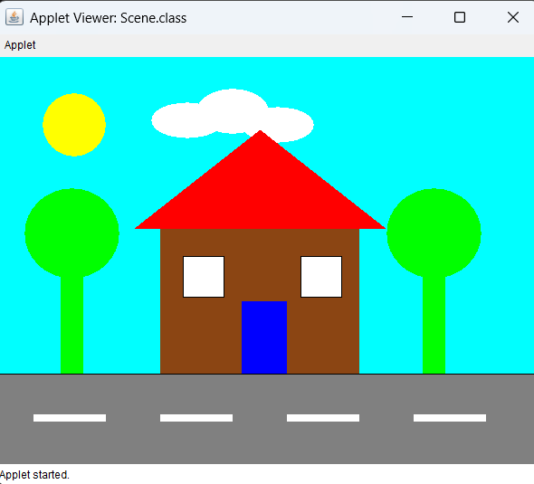

3.JAVA APPLET CALCULATOR :-
JAVA CODE:
import java.applet.Applet;
import java.awt.Graphics;
public class ParameterCalculator extends Applet {
double num1, num2, result;
String operator;
public void init() {
num1 = Double.parseDouble(getParameter("num1"));
num2 = Double.parseDouble(getParameter("num2"));
operator = getParameter("operator");
if (operator.equals("+"))
result = num1 + num2;
else if (operator.equals("-"))
result = num1 - num2;
else if (operator.equals("*"))
result = num1 * num2;
else if (operator.equals("/"))
result = num1 / num2;
}
public void paint(Graphics g) {
g.drawString("Number 1: " + num1, 50, 60);
g.drawString("Number 2: " + num2, 50, 90);
g.drawString("Operator: " + operator, 50, 120);
g.drawString("Result: " + result, 50, 150);
}
}
HTML CODE:
<html>
<body>
<applet code="ParameterCalculator.class" width="400" height="250">
<param name="num1" value="20">
<param name="num2" value="5">
<param name="operator" value="+">
</applet>
</body>
</html>
OUTPUT:
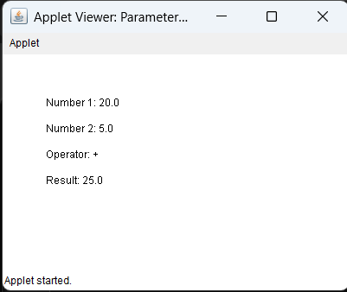
4.STUDENT PROFILE:-
JAVA CODE:
import java.awt.*;
import java.awt.event.*;
public class StudentProfile extends Frame implements ActionListener {
TextField name, regno;
Checkbox male, female;
CheckboxGroup gender;
Choice department, year;
List skills;
TextArea output;
Button generate;
public StudentProfile() {
setTitle("Student Profile");
setSize(650, 650);
setLayout(new BorderLayout(10, 10));
setBackground(Color.WHITE);
Label heading = new Label("STUDENT PROFILE", Label.CENTER);
heading.setFont(new Font("Arial", Font.BOLD, 24));
heading.setForeground(Color.BLUE);
add(heading, BorderLayout.NORTH);
Panel form = new Panel(new GridLayout(6, 2, 10, 10));
form.setBackground(new Color(220, 240, 255));
form.add(new Label("Name:"));
name = new TextField();
form.add(name);
form.add(new Label("Register Number:"));
regno = new TextField();
form.add(regno);
form.add(new Label("Gender:"));
Panel genderPanel = new Panel();
gender = new CheckboxGroup();
male = new Checkbox("Male", gender, false);
female = new Checkbox("Female", gender, false);
genderPanel.add(male);
genderPanel.add(female);
form.add(genderPanel);
form.add(new Label("Department:"));
department = new Choice();
department.add("CSE");
department.add("IT");
department.add("ECE");
department.add("EEE");
department.add("MECH");
form.add(department);
form.add(new Label("Year:"));
year = new Choice();
year.add("1st Year");
year.add("2nd Year");
year.add("3rd Year");
year.add("4th Year");
form.add(year);
form.add(new Label("Skills / Programming Languages:"));
skills = new List(4, true);
skills.add("Java");
skills.add("Python");
skills.add("C");
skills.add("C++");
skills.add("HTML");
skills.add("SQL");
form.add(skills);
generate = new Button("Generate Report");
generate.setBackground(Color.GREEN);
generate.setForeground(Color.WHITE);
generate.addActionListener(this);
Panel center = new Panel(new BorderLayout(10, 10));
center.add(form, BorderLayout.CENTER);
center.add(generate, BorderLayout.SOUTH);
add(center, BorderLayout.CENTER);
output = new TextArea();
output.setEditable(false);
output.setBackground(new Color(245, 235, 255));
add(output, BorderLayout.SOUTH);
addWindowListener(new WindowAdapter() {
public void windowClosing(WindowEvent e) {
System.exit(0);
}
});
setVisible(true);
}
public void actionPerformed(ActionEvent e) {
String selectedGender = "";
if (male.getState())
selectedGender = "Male";
else if (female.getState())
selectedGender = "Female";
String[] selectedSkills = skills.getSelectedItems();
String skillText = "";
for (int i = 0; i < selectedSkills.length; i++) {
skillText += selectedSkills[i] + " ";
}
output.setText(
"STUDENT PROFILE\n\n" +
"Name: " + name.getText() + "\n" +
"Register Number: " + regno.getText() + "\n" +
"Gender: " + selectedGender + "\n" +
"Department: " + department.getSelectedItem() + "\n" +
"Year: " + year.getSelectedItem() + "\n" +
"Skills: " + skillText
);
}
public static void main(String[] args) {
new StudentProfile();
}
}
OUTPUT:
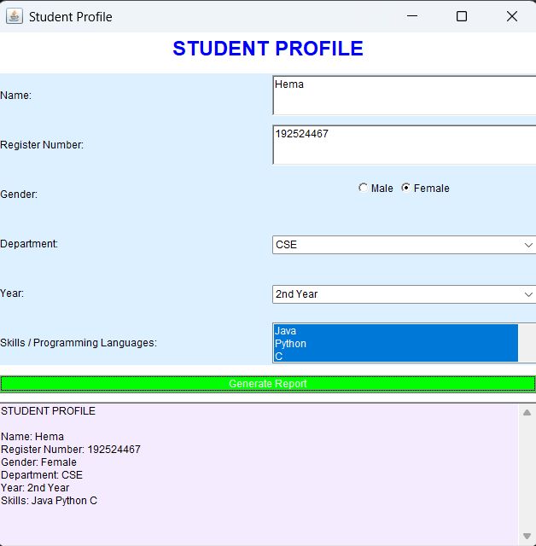
5.GRID LAYOUT :-
JAVA CODE:
import java.awt.*;
import java.awt.event.*;

public class GridCalculator extends Frame implements ActionListener {
TextField display;
double num1, num2, result;
char operator;
public GridCalculator() {
setTitle("Grid Calculator");
setSize(400, 500);
setLayout(new BorderLayout(10, 10));
display = new TextField();
display.setEditable(false);
display.setFont(new Font("Arial", Font.BOLD, 24));
add(display, BorderLayout.NORTH);
Panel panel = new Panel();
panel.setLayout(new GridLayout(4, 4, 5, 5));
String[] buttons = {
"7", "8", "9", "+",
"4", "5", "6", "-",
"1", "2", "3", "*",
"0", "=", "C", "/"
};
for (int i = 0; i < buttons.length; i++) {
Button b = new Button(buttons[i]);
b.setFont(new Font("Arial", Font.BOLD, 20));
b.addActionListener(this);
panel.add(b);
}
add(panel, BorderLayout.CENTER);
addWindowListener(new WindowAdapter() {
public void windowClosing(WindowEvent e) {
System.exit(0);
}
});
setVisible(true);
}
public void actionPerformed(ActionEvent e) {
String s = e.getActionCommand();
if (s.equals("C")) {
display.setText("");
num1 = 0;
num2 = 0;
result = 0;
}
else if (s.equals("+") || s.equals("-") ||
s.equals("*") || s.equals("/")) {
if (!display.getText().equals("")) {
num1 = Double.parseDouble(display.getText());
operator = s.charAt(0);
display.setText("");
}
}
else if (s.equals("=")) {
if (!display.getText().equals("")) {
num2 = Double.parseDouble(display.getText());
if (operator == '+')
result = num1 + num2;
else if (operator == '-')
result = num1 - num2;
else if (operator == '*')
result = num1 * num2;
else if (operator == '/')
result = num1 / num2;
display.setText(String.valueOf(result));
}
}
else {
display.setText(display.getText() + s);
}
}
public static void main(String[] args) {
new GridCalculator();
}
}
OUTPUT:
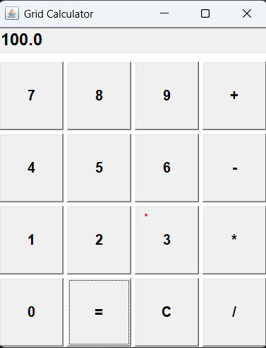

6.GRIDBAG LAYOUT :-
JAVA CODE:
import java.awt.*;
import java.awt.event.*;
public class StudentRegistration extends Frame implements ActionListener {
TextField name, regno, email;
Choice department, year;
Checkbox male, female;
CheckboxGroup gender;
Button submit, reset;
TextArea output;
public StudentRegistration() {
setTitle("Student Registration Form");
setSize(650, 650);
setLayout(new GridBagLayout());
setBackground(Color.WHITE);
GridBagConstraints gbc = new GridBagConstraints();
gbc.insets = new Insets(8, 8, 8, 8);
gbc.fill = GridBagConstraints.HORIZONTAL;
Label heading = new Label("STUDENT REGISTRATION FORM", Label.CENTER);
heading.setFont(new Font("Arial", Font.BOLD, 24));
heading.setForeground(Color.BLUE);
gbc.gridx = 0;
gbc.gridy = 0;
gbc.gridwidth = 2;
add(heading, gbc);
gbc.gridwidth = 1;
gbc.gridx = 0;
gbc.gridy = 1;
add(new Label("Name:"), gbc);
name = new TextField(20);
gbc.gridx = 1;
add(name, gbc);
gbc.gridx = 0;
gbc.gridy = 2;
add(new Label("Register Number:"), gbc);
regno = new TextField(20);
gbc.gridx = 1;
add(regno, gbc);
gbc.gridx = 0;
gbc.gridy = 3;
add(new Label("Department:"), gbc);
department = new Choice();
department.add("CSE");
department.add("IT");
department.add("ECE");
department.add("EEE");
department.add("MECH");
gbc.gridx = 1;
add(department, gbc);
gbc.gridx = 0;
gbc.gridy = 4;
add(new Label("Email:"), gbc);
email = new TextField(20);
gbc.gridx = 1;
add(email, gbc);
gbc.gridx = 0;
gbc.gridy = 5;
add(new Label("Gender:"), gbc);
Panel genderPanel = new Panel();
gender = new CheckboxGroup();
male = new Checkbox("Male", gender, false);
female = new Checkbox("Female", gender, false);
genderPanel.add(male);
genderPanel.add(female);
gbc.gridx = 1;
add(genderPanel, gbc);
gbc.gridx = 0;
gbc.gridy = 6;
add(new Label("Year:"), gbc);
year = new Choice();
year.add("1st Year");
year.add("2nd Year");
year.add("3rd Year");
year.add("4th Year");
gbc.gridx = 1;
add(year, gbc);
submit = new Button("Submit");
submit.setBackground(Color.GREEN);
submit.setForeground(Color.WHITE);
submit.addActionListener(this);
gbc.gridx = 0;
gbc.gridy = 7;
add(submit, gbc);
reset = new Button("Reset");
reset.setBackground(Color.RED);
reset.setForeground(Color.WHITE);
reset.addActionListener(this);
gbc.gridx = 1;
add(reset, gbc);
output = new TextArea(5, 30);
output.setEditable(false);
output.setBackground(new Color(235, 245, 255));
gbc.gridx = 0;
gbc.gridy = 8;
gbc.gridwidth = 2;
add(output, gbc);
addWindowListener(new WindowAdapter() {
public void windowClosing(WindowEvent e) {
System.exit(0);
}
});
setVisible(true);
}
public void actionPerformed(ActionEvent e) {
if (e.getSource() == submit) {
String selectedGender = "";
if (male.getState())
selectedGender = "Male";
else if (female.getState())
selectedGender = "Female";
output.setText(
"STUDENT REGISTRATION DETAILS\n\n" +
"Name: " + name.getText() + "\n" +
"Register Number: " + regno.getText() + "\n" +
"Department: " + department.getSelectedItem() + "\n" +
"Email: " + email.getText() + "\n" +
"Gender: " + selectedGender + "\n" +
"Year: " + year.getSelectedItem()
);
}
if (e.getSource() == reset) {
name.setText("");
regno.setText("");
email.setText("");
output.setText("");
department.select(0);
year.select(0);
male.setState(false);
female.setState(false);
}
}
public static void main(String[] args) {
new StudentRegistration();
}
}

OUTPUT:
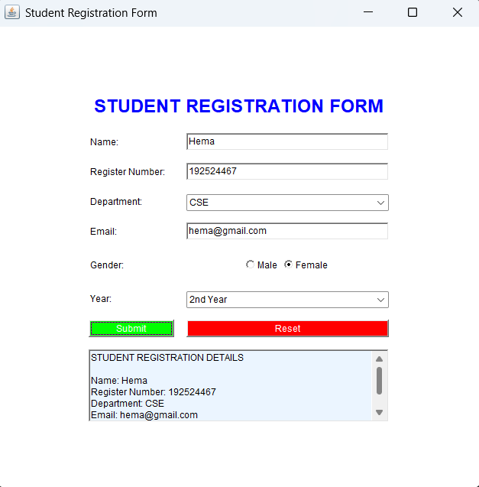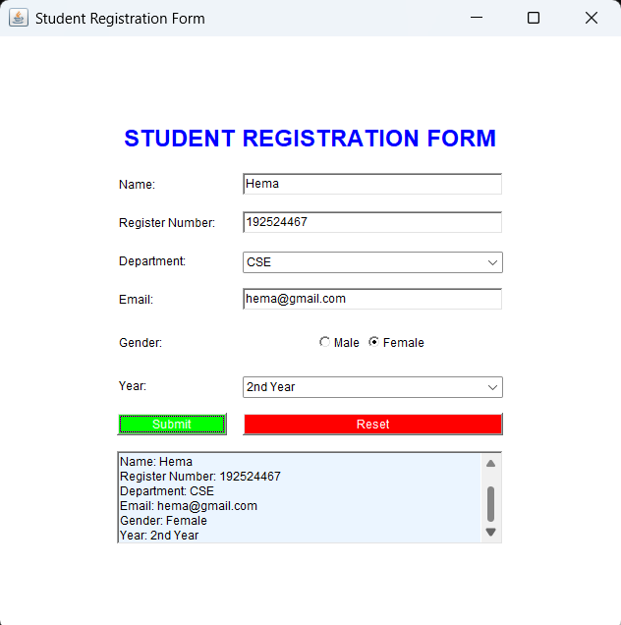

7.BORDER LAYOUT:
JAVA CODE:
import java.awt.*;
import java.awt.event.*;
public class BorderLayoutDemo extends Frame implements ActionListener {
TextArea display;
Button home, profile, settings;
Button option1, option2;
Button submit, clear;
public BorderLayoutDemo() {
setTitle("BorderLayout Application");
setSize(700, 500);
setLayout(new BorderLayout(10, 10));
Label header = new Label("STUDENT INFORMATION SYSTEM", Label.CENTER);
header.setFont(new Font("Arial", Font.BOLD, 22));
header.setForeground(Color.BLUE);
add(header, BorderLayout.NORTH);
Panel menu = new Panel(new GridLayout(3, 1, 5, 5));
home = new Button("Home");
profile = new Button("Profile");
settings = new Button("Settings");
menu.add(home);
menu.add(profile);
menu.add(settings);
home.addActionListener(this);
profile.addActionListener(this);
settings.addActionListener(this);
add(menu, BorderLayout.WEST);
Panel options = new Panel(new GridLayout(2, 1, 5, 5));
option1 = new Button("Option 1");
option2 = new Button("Option 2");
options.add(option1);
options.add(option2);
option1.addActionListener(this);
option2.addActionListener(this);
add(options, BorderLayout.EAST);
display = new TextArea();
display.setEditable(false);
display.setText("Welcome to Student Information System");
display.setFont(new Font("Arial", Font.PLAIN, 16));
add(display, BorderLayout.CENTER);
Panel buttons = new Panel();
submit = new Button("Submit");
clear = new Button("Clear");
submit.setBackground(Color.GREEN);
submit.setForeground(Color.WHITE);
clear.setBackground(Color.RED);
clear.setForeground(Color.WHITE);
buttons.add(submit);
buttons.add(clear);
submit.addActionListener(this);
clear.addActionListener(this);
add(buttons, BorderLayout.SOUTH);
addWindowListener(new WindowAdapter() {
public void windowClosing(WindowEvent e) {
System.exit(0);
}
});
setVisible(true);
}
public void actionPerformed(ActionEvent e) {
String button = e.getActionCommand();
if (button.equals("Home"))
display.setText("HOME\n\nWelcome to the Student Information System.");
else if (button.equals("Profile"))
display.setText("PROFILE\n\nStudent profile information.");
else if (button.equals("Settings"))
display.setText("SETTINGS\n\nSystem settings and preferences.");
else if (button.equals("Option 1"))
display.setText("OPTION 1\n\nOption 1 selected.");
else if (button.equals("Option 2"))
display.setText("OPTION 2\n\nOption 2 selected.");
else if (button.equals("Submit"))
display.setText("SUBMITTED\n\nInformation submitted successfully.");
else if (button.equals("Clear"))
display.setText("");
}
public static void main(String[] args) {
new BorderLayoutDemo();
}
}

OUTPUT:
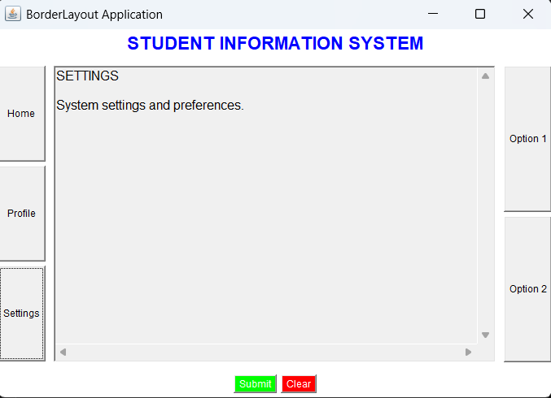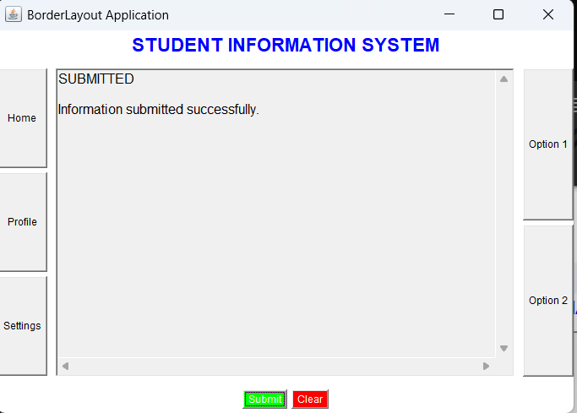

8.CARD LAYOUT:-
JAVA CODE:
import java.awt.*;
import java.awt.event.*;
public class CardLayoutDemo extends Frame implements ActionListener {
CardLayout cardLayout;
Panel cards;
Button next, previous, submit;
TextField name, regno, course, marks;
Choice year, semester;
TextArea report;
public CardLayoutDemo() {
setTitle("Student Information");
setSize(600, 450);
setLayout(new BorderLayout());
cardLayout = new CardLayout();
cards = new Panel(cardLayout);
Panel card1 = new Panel(new GridLayout(3, 2, 10, 10));
card1.add(new Label("Student Name:"));
name = new TextField();
card1.add(name);
card1.add(new Label("Register Number:"));
regno = new TextField();
card1.add(regno);
card1.add(new Label("Course:"));
course = new TextField();
card1.add(course);
Panel card2 = new Panel(new GridLayout(3, 2, 10, 10));
card2.add(new Label("Year:"));
year = new Choice();
year.add("1st Year");
year.add("2nd Year");
year.add("3rd Year");
year.add("4th Year");
card2.add(year);
card2.add(new Label("Semester:"));
semester = new Choice();
semester.add("Semester 1");
semester.add("Semester 2");
semester.add("Semester 3");
semester.add("Semester 4");
semester.add("Semester 5");
semester.add("Semester 6");
semester.add("Semester 7");
semester.add("Semester 8");
card2.add(semester);
card2.add(new Label("Marks:"));
marks = new TextField();
card2.add(marks);
Panel card3 = new Panel(new BorderLayout());
report = new TextArea();
report.setEditable(false);
card3.add(report, BorderLayout.CENTER);
cards.add(card1, "Student Information");
cards.add(card2, "Academic Information");
cards.add(card3, "Confirmation/Report");
add(cards, BorderLayout.CENTER);
Panel buttons = new Panel();
previous = new Button("Previous");
next = new Button("Next");
submit = new Button("Submit");
buttons.add(previous);
buttons.add(next);
buttons.add(submit);
previous.addActionListener(this);
next.addActionListener(this);
submit.addActionListener(this);
add(buttons, BorderLayout.SOUTH);
addWindowListener(new WindowAdapter() {
public void windowClosing(WindowEvent e) {
System.exit(0);
}
});
setVisible(true);
}
public void actionPerformed(ActionEvent e) {
String command = e.getActionCommand();
if (command.equals("Next")) {
cardLayout.next(cards);
}
else if (command.equals("Previous")) {
cardLayout.previous(cards);
}
else if (command.equals("Submit")) {
report.setText(
"CONFIRMATION / REPORT\n\n" +
"Student Name: " + name.getText() + "\n" +
"Register Number: " + regno.getText() + "\n" +
"Course: " + course.getText() + "\n" +
"Year: " + year.getSelectedItem() + "\n" +
"Semester: " + semester.getSelectedItem() + "\n" +
"Marks: " + marks.getText()
);
cardLayout.show(cards, "Confirmation/Report");
}
}
public static void main(String[] args) {
new CardLayoutDemo();
}
}

OUTPUT:
